Multiple-choice section – choose the correct answer

Question 1 [9.1]

A jar is filled with 1000 jelly beans. A random sample of 15 is taken from the jar and it is found to contain 2 black, 4 green, 6 red and the rest orange. Of the 1000 jelly beans in the jar, the expected number of black jelly beans and orange jelly beans, respectively, would be:

A 267, 200 B 267, 300 C 133, 300 D 133, 200

Question 2 [9.1]

400 penguins were tagged and released into the population. Of a sample of 120 penguins that were caught later, 15 were found to have tags. The estimated population size is:

A 50 B 3200 C 4000 D 4500

Question 3 [9.2]

The range is:

A the score that occurs the most

B the average set of scores

C the difference between the highest score and the lowest score

D the middle score of a set of scores

Question 4 [9.5]

Any possible result of an event is called:

A an outcome B the sample space

C the complement D the probability

Question 5 [9.6]

A card is drawn from a standard pack of 52 playing cards. What is the probability it is a heart?

A  B  C  D 

Question 6 [9.7]

In a Venn diagram, the symbol used to represent the universal set is:

A *A* B *A*′ C ξ D *B*

Question 7 [9.6]

Twenty cards, each with a different number from 1 to 20 written on it, are placed in a hat. One number is drawn. What is the probability it is a number with a 1 in it?

A  B  C  D 

Question 8 [9.4]

The class centre for a class interval of 25–34 is:

A 29 B 29.5 C 30 D 30.5

Multiple-choice results: ___ /8

Short answer section

Question 9 2 marks [9.7]

Choose the correct word from the following list to fill each of the gaps in the following sentences.

*probability outcome union intersection set*

(a) A Venn diagram or a two-way table can be used to work out the ____________________ of an outcome occurring from overlapping events.

(b) The ____________________ of *A* and *B* includes the outcomes that are in both *A* and *B*.

Question 10 2 marks [9.1]

Using an example, explain the term ‘random sampling’.

Question 11 2 marks [9.1]

Choose the example from the list below that is both a ‘judgemental’ and a ‘convenience’ sample. Explain your choice.

Example 1 Surveying a group of school tuckshop volunteers on what makes a healthy school lunch.

Example 2 Surveying scientists from all over the world in regards to rising ocean levels.

Example 3 Asking people who enter a shopping mall their opinion on new government reforms.

For your chosen example, is there a likelihood of bias? Explain your answer.

Question 12 3 marks [9.6]

The table shows the number of children in a family and the probability of a family having that number of children.

(a) Complete the table by filling in the missing probability for having 5 children in the family.

|  |  |
| --- | --- |
| Children in the family | Probability |
| 0 | 0.12 |
| 1 | 0.26 |
| 2 | 0.31 |
| 3 | 0.17 |
| 4 | 0.08 |
| 5 |  |
| > 5 | 0.02 |

(b) A town has 850 families. Calculate the number of families that would have:

(i) 3 or 4 children

(ii) at least 2 children.

Question 13 8 marks [9.4]

(a) For the data in the table, find the mean, median, mode and range.

|  |  |
| --- | --- |
| *x* | *f* |
| 11  12  13  14  15 | 1  0  3  12  4 |

(b) If each of the data of value 15 was replaced with data of value 20, what effect would this have on the values calculated in (a)?

Question 14 6 marks [9.3]

For the following discrete data:

25, 14, 16, 18, 9, 8, 14, 12, 11, 25, 10, 15, 10, 22, 16, 18, 8, 19, 13, 13, 7, 25, 4, 1, 23, 7, 14, 23, 1, 7

(a) construct a frequency table with the grouped data

|  |  |  |
| --- | --- | --- |
| Class interval | Tally | Frequency |
| 1–5 |  |  |

(b) draw a frequency column graph of the data.

Question 15 5 marks [9.4]

(a) For the following stem-and-leaf plot:

|  |  |  |
| --- | --- | --- |
| **Stem** | **Leaf** |  |
| 0 | 6 7 |  |
| 1 | 4 7 |  |
| 2 | 1 3 3 3 5 5 |  |
| 3 | 1 4 5 7 |  |
| 4 | 2 6 | Key: 2 | 3 = 23 |

(i) find the median

(ii) calculate the mean.

(b) Using classes 0–9, 10–19 and so on, estimate the mean from the grouped data and compare this with the mean calculated above.

Question 16 3 marks [9.5]

A spinning wheel has the numbers 1 to 54 equally spaced around the wheel. The wheel is spun and lands on one number at random.

(a) Calculate the probability the wheel lands on a multiple of 10.

(b) What is the complement of getting a number with a 2 in it?

Question 17 3 marks [9.6]

The letters of the word MATHEMATICS are written on individual cards. A card is chosen at random. Find the probability that:

(a) the letter ‘A’ is selected

(b) the letter selected is a vowel

(c) the letter selected is one of the letters in the word MATE.

Question 18 4 marks [9.6]

For a standard pack of 52 playing cards, find the following probabilities:

(a) Pr(black or a 4)

(b) Pr(black 4)

(c) Pr(black or 4 but not both)

Question 19 4 marks [9.7]

The Venn diagram shows students who play the piano (P) and play the guitar (G). If one person is chosen at random, find the probability that:

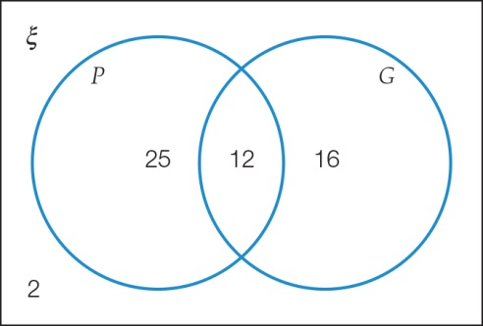

(a) a student plays piano

(b) a student plays guitar or piano

(c) a student plays guitar and piano

(d) a student plays guitar or piano but not both.

Question 20 4 marks [9.7]

Use the following information to answer the questions.

ξ = {numbers from 1 to 12}

Event *A* = {factors of 20}

Event *B* = {prime numbers}

(a) List the elements of *A* and the elements of *B*.

*A*:

*B*:

(b) If one number is randomly selected, find:

(i) Pr(*A*′)

(ii) Pr(*A* or *B*)

Question 21 3 marks [9.7]

Use the Venn diagram to find:

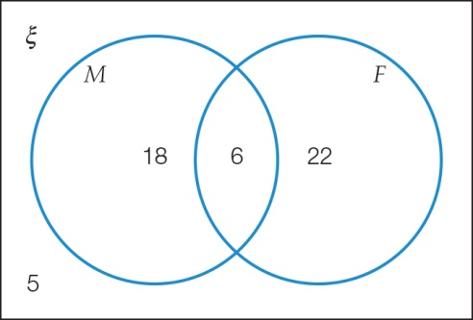

(a) *n*(ξ)

(b) Pr(*M* and *F*)

(c) Pr(*M*′)

Question 22 4 marks [9.7]

In a group of 25 students, 16 students have a cat, 19 students have a dog and three students have neither a cat or a dog.

(a) Complete the two-way table.

|  |  |  |  |
| --- | --- | --- | --- |
|  | Cat | No cat |  |
| Dog |  |  |  |
| No dog |  |  |  |
|  |  |  | 25 |

(b) Find the probability that a student chosen at random has a cat and a dog.

Short answer results: ___ / 53

Extended answer section

Question 23 12 marks [9.3, 9.4, 9.5]

The following frequency distribution table is incomplete.

(a) Fill in the missing information.

|  |  |  |  |
| --- | --- | --- | --- |
| Class interval | *x* | Frequency (*f*) | *xf* |
| 25–<30 | 27.5 | 8 |  |
| 30–<35 |  | 12 |  |
| 35–<40 |  | 14 |  |
| 40–<45 |  | 16 |  |
| 45–<50 |  | 15 |  |
| 50–<55 |  | 13 |  |
| 55–<60 |  | 12 |  |
|  |  | Σ*f* = | Σ*xf* = |

(b) If a histogram was drawn from the table, what values would be along the horizontal axis?

(c) Find:

(i) the estimated mean

(ii) the modal class interval

(iii) the median class interval.

(d) If a data value was selected at random, what is the probability it is less than 45?

(e) If there are three additional data all belonging to the interval 45–<50, what happens to the values of:

(i) the estimated mean

(ii) the modal class

(iii) the median class?

(f) Recalculate the probability that the randomly selected data value is less than 45.

Question 24 6 marks [9.3, 9.4, 9.5]

The following is a frequency histogram for 40 people and how much time (in minutes) they spent one day at a local shopping centre.

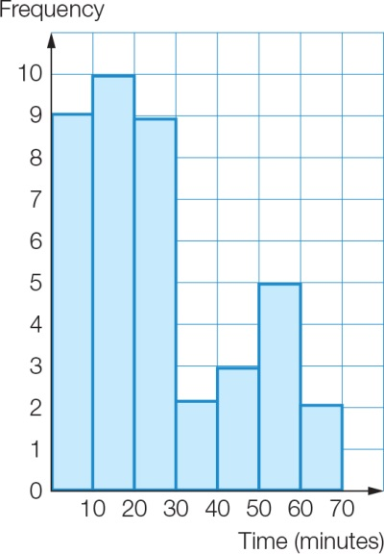

(a) Construct a frequency table from the histogram.

(b) What is the probability that a person selected at random spent more than 30 minutes at the shopping centre?

(c) Calculate an estimate for the mean amount of time each person stayed at the shopping centre.

Question 25 10 marks [9.1]

Adam Spencer’s *The big book of numbers* has a section that is 161 words long. Six sets of 10 words from this section were randomly selected:

Set A: string, to, intimately, world, of, think, move, saw, But, understand

Set B: looks, called, Universe, dimension, called, of, more, time, the, so

Set C: moving, similarly, sometimes, in, see, world, our, we, extra, our

Set D: spiral, might, for, dimensional, suggested, be, connected, showed, from, of

Set E: the, use, that, in, bosonic, space, just, that, Similarly, of

Set F: lives, a, everyday, Similarly, In, time, our, He, away, for

(a) For each set find:

(i) the mean number of letters per word

(ii) the proportion of words that contain the letter ‘a’.

(b) Pair the sets (A with B etc) to make three sets of 20 words and repeat the process from part (a).

(c) Describe what happened to the variation in the values of the sample means and sample proportions when the sample size increased.

Question 26 4 marks [9.6, 9.7]

A restaurant offers four entrees (soup, spring rolls, prawn toast and dumplings) and five main courses (pork, chicken, honey prawns, lamb and garlic prawns).

(a) List all the possible different meal combinations.

(b) A customer cannot eat prawns. If a dish is selected at random, what is the probability that the customer will get a meal they can eat?

Question 27 7 marks [9.7]

The Venn diagram represents the number of teenagers who participate every week in one or more sports. *A*, *B* and *C* each represent a different sport. Find the following probabilities:

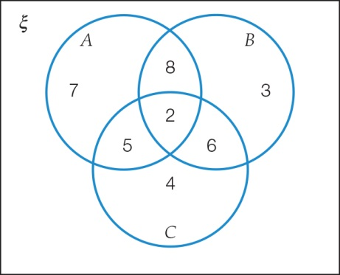

(a) Pr(*A* or *B*)

(b) Pr(*A* and *B*)

(c) Pr(*A* or *B* or *C*)

(d) Pr(*A*‘)

(e) Pr(*B* or *C* but not both)

(f) Pr(participation in at least 2 sports)

(g) Pr(participation in exactly 2 sports)

Extended answer results: ___ / 39

TOTAL test results: ___ / 100